Business Case - Template
Use this template to create your business case document. In this example, we are using the Build a Recruiting App example. You’ll replace these items with content that’s relevant to the scenario you’re using and the problem you are solving.

Executive Summary
Short description of what the proposed project is and what problem it solves.

Example:
Build a recruiting app that provides recruiters with a way to manage job postings and potential candidates. Automate the approval process and improve data quality and security.

Current Process
Include a process flow diagram or detailed description of the steps in the current process.

Example:
The current process requires manual tracking, approvals, and emails:
- Post jobs on multiple job sites
- Receive incoming applications
- Review applications
- Reject applications and send emails
- Move shortlisted applications to the next step.
- Send emails to shortlisted applicants
- Schedule interviews
- Log feedback
- Reject candidates and send emails
- Schedule the second interview for approved applicants
- Reject candidates and send emails
- Remove job postings from multiple sites

Proposed New Process
Include a process flow diagram or detailed description of the new proposed process.

Example:
- Post jobs on multiple sites and update the job posting record in Salesforce
- Applicants are entered into Salesforce as leads. Applicants automatically get a thank you email.
- Application reviewer marks applicants as rejected or approved to the next step. Automated emails sent to declined applicants. Automatic email sent to approved applicants to schedule interviews.
- Round 2 results recorded. Automatic emails sent.
- Final round applicant interviews scheduled.
- Manager approval to offer the job is automated.

Example process flow:

  - 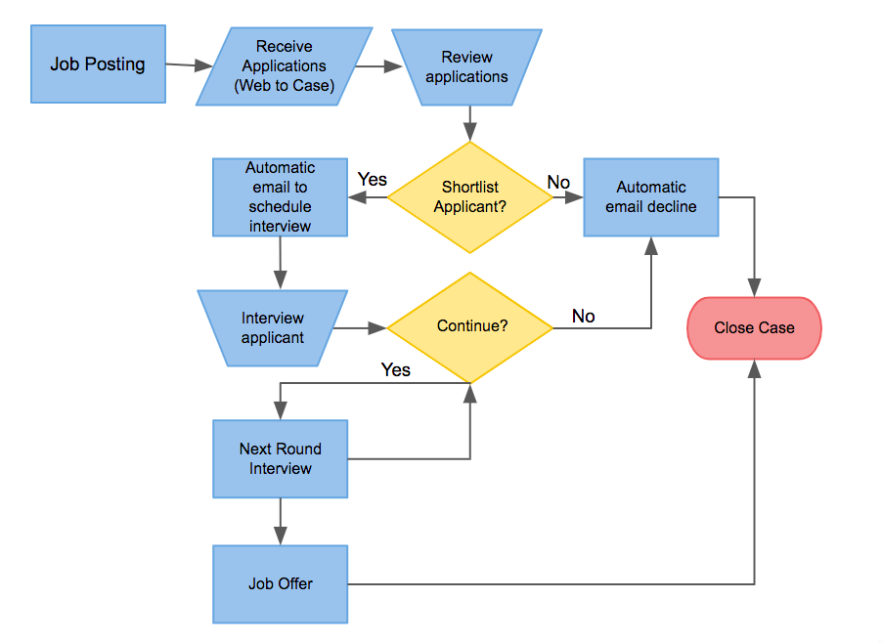

Recommendations
This is the product you are recommending; you have done the homework; you will want to explain why this product and the benefits. Remember to keep it non-techy.

Example:
We recommend that you implement this solution to automate the tracking, approval, and communications for job applicants to streamline the process and be a good experience for candidates.

This solution automates several tasks for the recruiter, thereby saving time from manual tasks like follow-up emails and scheduling interviews.

Additionally, this solution ensures data quality and security, ensuring that only those who have the correct permission sets can access the information and act on it.

Timeline
It is recommended that you include an estimated timeline. The Timeline provides insight into how long you think the project will take as well as the necessary resources needed. The estimated timeline can be written out in a tablet or a Gantt chart.

Example:
Download a free Gantt Chart from Tableau

Financial Impact
The financial impact is the investment the company is required to make for the project to go live. The total impact should be broken down into segments. For example, the cost of the materials, people required for the project, and the department that investment will affect. You will also want to include what the estimated Return on Investment (ROI) would be and the estimated time frame before that return is seen.

